Principles of Database Management

Midterm Test – 20_School Management System

Group member:

* Trần Trọng Thức ITITIU18125
* Nguyễn Lê Thanh Tâm ITITIU18110
* Nguyễn Đức Đăng Khôi ITITIU18066

# Question part:

Topic 20 – School Management System Design a database to maintain information about school staff and students satisfying following properties:

- Staff will be having their id, name and classes they are teaching

- Student will be having name, roll no, section, class

- Another table containing section, subject and teacher information

- Next will be containing fee information for students

- One contains salary information for teachers

- Rooms are assigned to classes keeping in mind that there is no time clash of same room or lab, student cannot be entered in more than one section, no student should be there who has not paid fee up to a particular date.

Answer part:

1. Designing an ERD conceptual schema:

The school management system will manage the information of the student and staff in the school. It will contain the data of student, their id, name, the subject, and class that they are enrolled and the staff teaching them.

Requirements:

1. A student has student ID, student name, gender, level and join in one class.
2. A staff has staff ID, staff name, and a salary.
3. A student has one or many tuition fee (ex: one semester - one fee).
4. A staff has one and only one salary.
5. Subjects which have the same name, can have different subject IDs.
6. A student can learn many subjects which have different subject name.
7. A staff can give subject assignments.
8. Students, staffs, subjects and rooms are allocated together to form a class allocation.

Note:

* + **These are entity classes.**
  + These are cardinalities.
  + *These are relationships.*
  + These are attributes.
  + These are primary attributes.

**E-R Diagram includes:**

- A **Student** *joins in* one **Class**, a **Class** *has* many **Student**.

- A **Student** *has* one or many **Student** **Fee**(s), a **Student** Fee *is* *paid* *by* one and only one Student.

- A **Staff** *receives* one **Staff** **Salary**, a **Staff** **Salary** *is* *owned* *by* one and only one **Staff**.

- A **Staff** *gives* one or many **Classroom** **Assignment**(s), a **Classroom** **Assignment** *is* *given* *by* one and only one **Staff**.

- A **Subject** *can* *has* one or many **Classroom** **Assignment**(s), a **Classroom** **Assignment** *is* *belonging* *to* one **Subject**.

- A **Student** *registers* one or many *registrations* *as* **Check** **Student** **Enrollment**(s), a **Check** **Student** **Enrollment** *is* *created* *by* one **Student**.

- A **Subject** *are* *located* *in* one or many registrations as **Check** **Student** **Enrollment**(s), a **Check** **Student** **Enrollment** *has* only one **Subject**.

- In the class allocation list, a **Subject** *is* *taught* *by* one **Staff** , a **Student** *is* *taught* *by* one or many **Staff**(s) (by registering many **Subject**(s)), and a **Staff** *can* *teach* one or many **Subject**(s)/**Student**(s).

**E-R Diagram Schemas:**

- **Student** (student_ID, student_name, student_gender, level).

- **Staff** (staff_ID, staff_name)

- **Class** (class_ID, class_section).

- **Subject** (subject_ID, subject_name, subject_group).

- **Student** **Fee** (fee_ID, fee, payment_status, day_of_payment).

- **Staff** **Salary** (salary, payment_status).

- **Check** **Student** **Enrollment** (enrollment_ID).

- **Classroom** **Assignment** (assignment_ID, staff_ID, subject_ID, assignment _details)

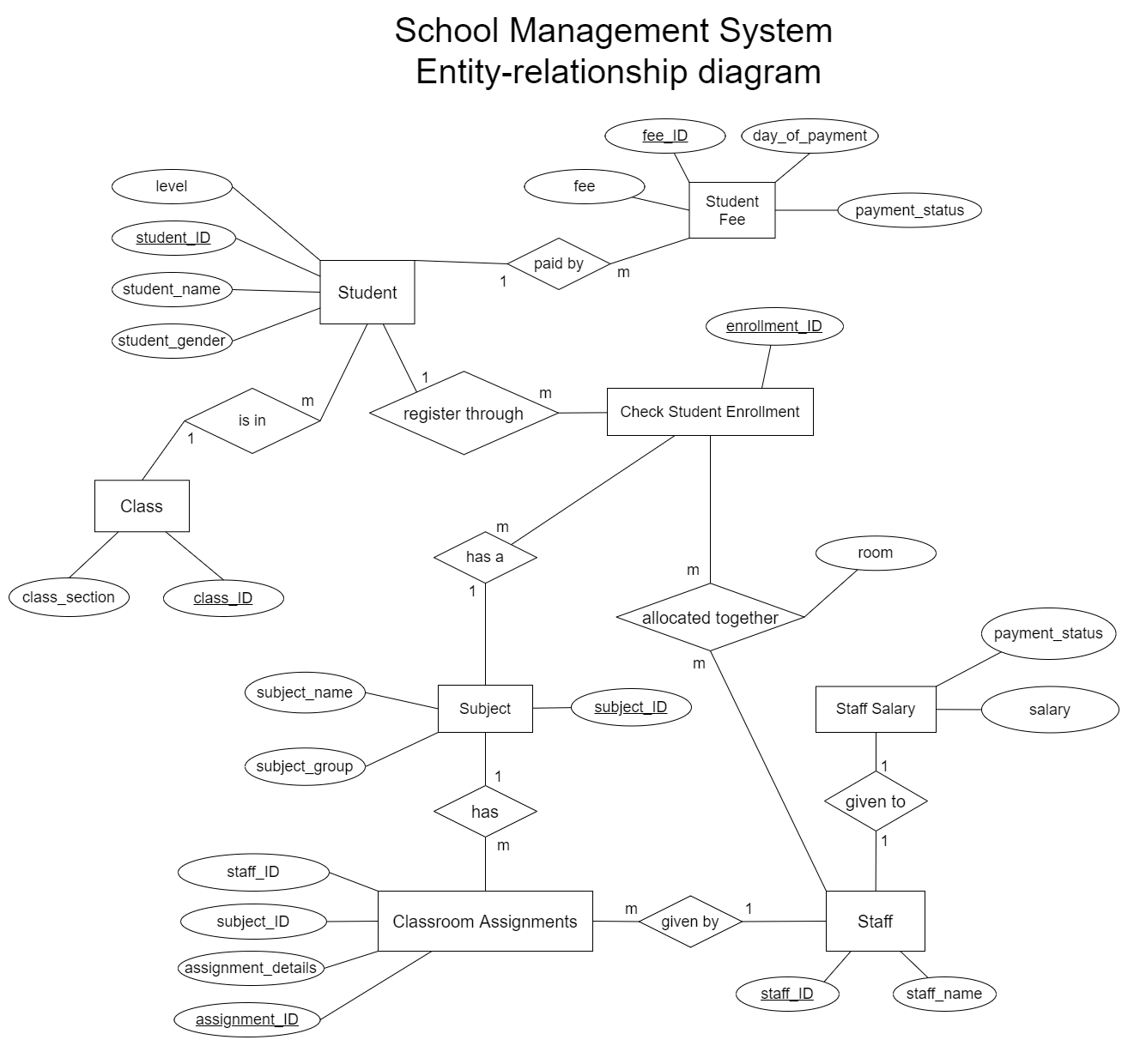

1. Converting from ERD to Relational Model:

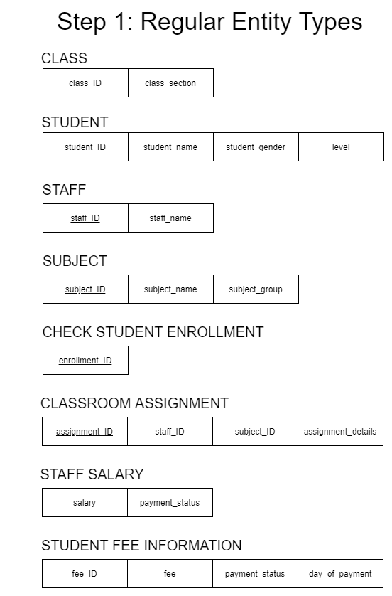

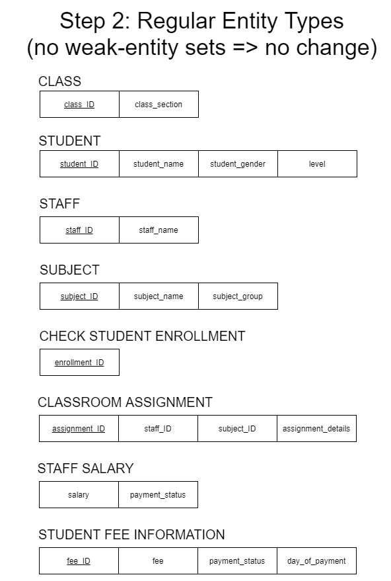

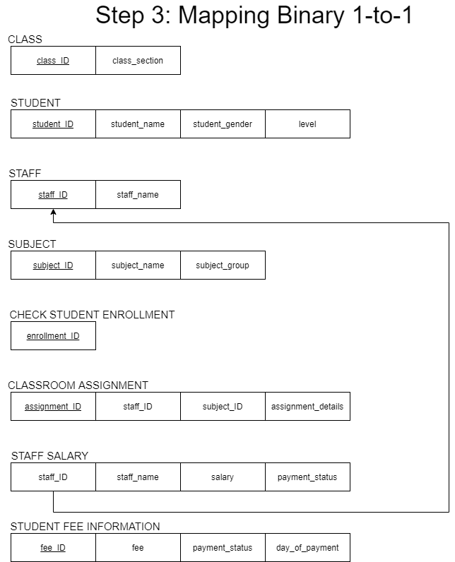

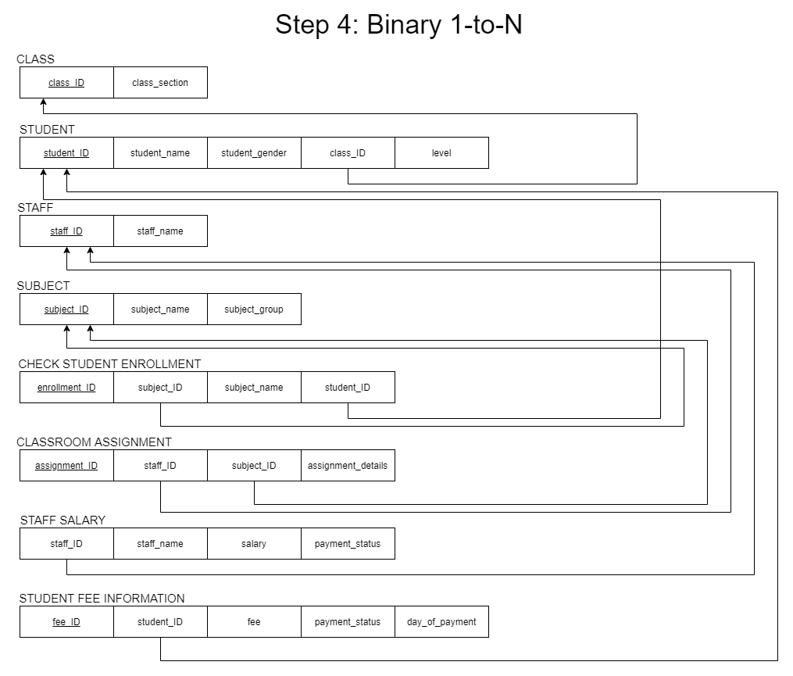

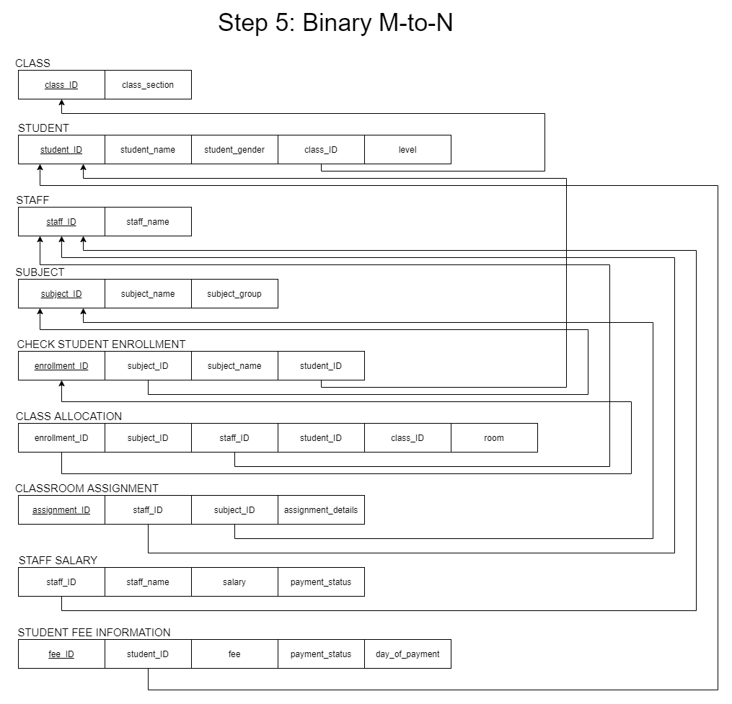

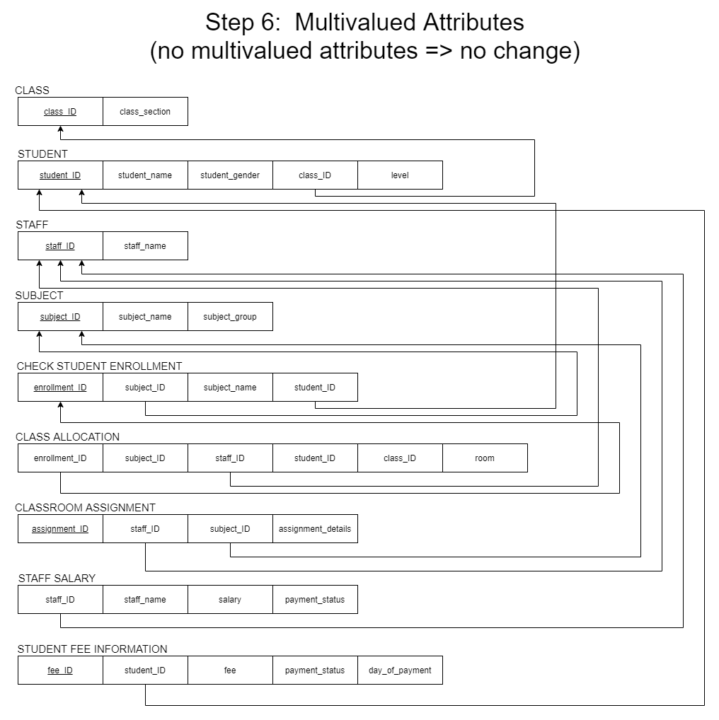

1. Create the database:

USE master

IF EXISTS (SELECT name FROM sys.databases WHERE name = 'SchoolManagementSystem')

DROP DATABASE SchoolManagementSystem;

GO

CREATE DATABASE SchoolManagementSystem;

GO

USE SchoolManagementSystem

GO

DROP TABLE IF EXISTS dbo.AdminCode

CREATE TABLE AdminCode(

access_code VARCHAR(6) UNIQUE,

CHECK (access_code LIKE '[0-9]%')

)

GO

DROP TABLE IF EXISTS dbo.Account

CREATE TABLE Account (

name VARCHAR(255),

username VARCHAR(255),

password VARCHAR(255),

role INT,

ID INT,

CHECK (password <> username),

UNIQUE (username, password)

)

GO

DROP TABLE IF EXISTS dbo.Class;

CREATE TABLE Class (

class_ID VARCHAR(255) PRIMARY KEY,

class_section VARCHAR(255) NOT NULL,

);

GO

DROP TABLE IF EXISTS dbo.Student;

CREATE TABLE Student (

student_ID INT PRIMARY KEY,

student_name VARCHAR(255) NOT NULL,

student_gender VARCHAR(6) NOT NULL,

class_ID VARCHAR(255) REFERENCES Class (class_ID)

ON DELETE CASCADE ON UPDATE SET NULL,

level VARCHAR(255) NOT NULL

);

GO

DROP TABLE IF EXISTS dbo.Staff;

CREATE TABLE Staff (

staff_ID INT PRIMARY KEY,

staff_name VARCHAR(255) NOT NULL,

);

GO

DROP TABLE IF EXISTS dbo.Subject;

CREATE TABLE Subject (

subject_ID VARCHAR(255) PRIMARY KEY,

subject_name VARCHAR(255) NOT NULL,

subject_group INT NOT NULL

)

GO

DROP TABLE IF EXISTS dbo.Check_student_enrollment;

CREATE TABLE Check_student_enrollment(

enrollment_ID INT PRIMARY KEY ,

student_ID INT REFERENCES Student (student_ID)

ON DELETE CASCADE ON UPDATE NO ACTION,

subject_name VARCHAR(255),

subject_ID VARCHAR(255) REFERENCES Subject (subject_ID)

ON DELETE CASCADE ON UPDATE SET NULL,

UNIQUE (student_ID, subject_name)

)

GO

DROP TABLE IF EXISTS dbo.Class_allocation;

CREATE TABLE Class_allocation (

enrollment_ID INT REFERENCES Check_student_enrollment(enrollment_ID)

ON DELETE CASCADE ON UPDATE CASCADE,

subject_ID VARCHAR(255) ,

staff_ID INT REFERENCES Staff (staff_ID)

ON DELETE SET NULL ON UPDATE SET NULL,

student_ID INT,

class_ID VARCHAR(255),

room VARCHAR(255) NOT NULL,

);

GO

DROP TABLE IF EXISTS dbo.Classroom_assignments;

CREATE TABLE Classroom_assignments (

assignment_ID INT PRIMARY KEY,

staff_ID INT REFERENCES Staff (staff_ID)

ON DELETE CASCADE ON UPDATE NO ACTION,

subject_ID VARCHAR(255) REFERENCES Subject (subject_ID)

ON DELETE CASCADE ON UPDATE NO ACTION,

assignment_details VARCHAR(255) NOT NULL,

);

GO

DROP TABLE IF EXISTS dbo.Staff_salary

CREATE TABLE Staff_salary (

staff_ID INT REFERENCES Staff (staff_ID)

ON DELETE CASCADE ON UPDATE NO ACTION,

staff_name VARCHAR(255) NOT NULL,

salary MONEY NOT NULL,

payment_status VARCHAR(3) DEFAULT 'NO'

);

GO

DROP TABLE IF EXISTS dbo.Student_fee_information

CREATE TABLE Student_fee_information (

fee_ID INT PRIMARY KEY,

student_ID INT REFERENCES Student (student_ID)

ON DELETE CASCADE ON UPDATE NO ACTION,

fee MONEY NOT NULL,

payment_status VARCHAR(3) DEFAULT 'NO',

day_of_payment DATE NOT NULL,

);

GO

--Here below are queries to import data from .xls (excel) files into the tables:

/* Before you can run a distributed query,

you have to enable the ad hoc distributed queries server configuration option, as shown in the following example.

sp_configure 'show advanced options', 1;

RECONFIGURE;

GO

sp_configure 'Ad Hoc Distributed Queries', 1;

RECONFIGURE;

GO

**COMMON ERRORS**

1) Microsoft.ACE.OLEDB.12.0" has not been registered

This error occurs because the OLEDB provider is not installed.

Install it from Microsoft Access Database Engine 2010 Redistributable.

Be sure to install the 64-bit version if Windows and SQL Server are both 64-bit.

The full error is:

[...]

The OLE DB provider "Microsoft.ACE.OLEDB.12.0" has not been registered.

Please download from below link and set up it.

https://www.microsoft.com/en-us/download/details.aspx?id=13255

2) Cannot create an instance of OLE DB provider "Microsoft.ACE.OLEDB.12.0" for linked server "(null)"

This indicates that the Microsoft OLEDB has not been configured properly.

The full error is:

[...]

Cannot create an instance of OLE DB provider "Microsoft.ACE.OLEDB.12.0" for linked server "(null)".

Run the following Transact-SQL code to resolve this:

EXEC sp_MSset_oledb_prop N'Microsoft.ACE.OLEDB.12.0', N'AllowInProcess', 1

EXEC sp_MSset_oledb_prop N'Microsoft.ACE.OLEDB.12.0', N'DynamicParameters', 1

3) The 32-bit OLE DB provider "Microsoft.ACE.OLEDB.12.0" cannot be loaded in-process on a 64-bit SQL Server

This occurs when a 32-bit version of the OLD DB provider is installed with a 64-bit SQL Server.

To resolve this issue, uninstall the 32-bit version and install the 64-bit version of the OLE DB provider instead.

The full error is:

[...]

The 32-bit OLE DB provider "Microsoft.ACE.OLEDB.12.0" cannot be loaded in-process on a 64-bit SQL Server.

4) For further error, please visit the link below:

https://docs.microsoft.com/en-us/sql/relational-databases/import-export/import-data-from-excel-to-sql?view=sql-server-ver15#common-errors

*/

-- Note: Please CHANGE the path name of address of all the import queries below:

DROP TABLE IF EXISTS dbo.ImportIntoTable

SELECT * INTO ImportIntoTable

FROM OPENROWSET('Microsoft.ACE.OLEDB.12.0',

'Excel 12.0; Database=C:\SQL Lab\ASSIGNMENT\Import Data - Excel Files\Admin_code.xls; HDR=YES; IMEX=1',

'SELECT * FROM [Sheet1$]');

GO

INSERT INTO AdminCode

SELECT * FROM ImportIntoTable

GO

DROP TABLE IF EXISTS dbo.ImportIntoTable

SELECT * INTO ImportIntoTable

FROM OPENROWSET('Microsoft.ACE.OLEDB.12.0',

'Excel 12.0; Database=C:\SQL Lab\ASSIGNMENT\Import Data - Excel Files\Account.xls; HDR=YES; IMEX=1',

'SELECT * FROM [Sheet1$]');

GO

INSERT INTO Account

SELECT * FROM ImportIntoTable

GO

DROP TABLE IF EXISTS dbo.ImportIntoTable

SELECT * INTO ImportIntoTable

FROM OPENROWSET('Microsoft.ACE.OLEDB.12.0',

'Excel 12.0; Database=C:\SQL Lab\ASSIGNMENT\Import Data - Excel Files\Class.xls; HDR=YES; IMEX=1',

'SELECT * FROM [Sheet1$]');

GO

INSERT INTO Class

SELECT * FROM ImportIntoTable

GO

DROP TABLE IF EXISTS dbo.ImportIntoTable

SELECT * INTO ImportIntoTable

FROM OPENROWSET('Microsoft.ACE.OLEDB.12.0',

'Excel 12.0; Database=C:\SQL Lab\ASSIGNMENT\Import Data - Excel Files\Student.xls; HDR=YES; IMEX=1',

'SELECT * FROM [Sheet1$]');

GO

INSERT INTO Student

SELECT * FROM ImportIntoTable

GO

DROP TABLE IF EXISTS dbo.ImportIntoTable

SELECT * INTO ImportIntoTable

FROM OPENROWSET('Microsoft.ACE.OLEDB.12.0',

'Excel 12.0; Database=C:\SQL Lab\ASSIGNMENT\Import Data - Excel Files\Staff.xls; HDR=YES; IMEX=1',

'SELECT * FROM [Sheet1$]');

GO

INSERT INTO Staff

SELECT * FROM ImportIntoTable

GO

DROP TABLE IF EXISTS dbo.ImportIntoTable

SELECT * INTO ImportIntoTable

FROM OPENROWSET('Microsoft.ACE.OLEDB.12.0',

'Excel 12.0; Database=C:\SQL Lab\ASSIGNMENT\Import Data - Excel Files\Subject.xls; HDR=YES; IMEX=1',

'SELECT * FROM [Sheet1$]');

GO

INSERT INTO Subject

SELECT * FROM ImportIntoTable

GO

DROP TABLE IF EXISTS dbo.ImportIntoTable

SELECT * INTO ImportIntoTable

FROM OPENROWSET('Microsoft.ACE.OLEDB.12.0',

'Excel 12.0; Database=C:\SQL Lab\ASSIGNMENT\Import Data - Excel Files\Check_student_enrollment.xls; HDR=YES; IMEX=1',

'SELECT * FROM [Sheet1$]');

GO

INSERT INTO Check_student_enrollment

SELECT * FROM ImportIntoTable

GO

DROP TABLE IF EXISTS dbo.ImportIntoTable

SELECT * INTO ImportIntoTable

FROM OPENROWSET('Microsoft.ACE.OLEDB.12.0',

'Excel 12.0; Database=C:\SQL Lab\ASSIGNMENT\Import Data - Excel Files\Class_allocation.xls; HDR=YES; IMEX=1',

'SELECT * FROM [Sheet1$]');

GO

INSERT INTO Class_allocation

SELECT * FROM ImportIntoTable

GO

DROP TABLE IF EXISTS dbo.ImportIntoTable

SELECT * INTO ImportIntoTable

FROM OPENROWSET('Microsoft.ACE.OLEDB.12.0',

'Excel 12.0; Database=C:\SQL Lab\ASSIGNMENT\Import Data - Excel Files\Classroom_assignments.xls; HDR=YES; IMEX=1',

'SELECT * FROM [Sheet1$]');

GO

INSERT INTO Classroom_assignments

SELECT * FROM ImportIntoTable

GO

DROP TABLE IF EXISTS dbo.ImportIntoTable

SELECT * INTO ImportIntoTable

FROM OPENROWSET('Microsoft.ACE.OLEDB.12.0',

'Excel 12.0; Database=C:\SQL Lab\ASSIGNMENT\Import Data - Excel Files\Staff_Salary.xls; HDR=YES; IMEX=1',

'SELECT * FROM [Sheet1$]');

GO

INSERT INTO Staff_Salary

SELECT * FROM ImportIntoTable

GO

DROP TABLE IF EXISTS dbo.ImportIntoTable

SELECT * INTO ImportIntoTable

FROM OPENROWSET('Microsoft.ACE.OLEDB.12.0',

'Excel 12.0; Database=C:\SQL Lab\ASSIGNMENT\Import Data - Excel Files\Student_fee_information.xls; HDR=YES; IMEX=1',

'SELECT * FROM [Sheet1$]');

GO

INSERT INTO Student_fee_information

SELECT * FROM ImportIntoTable

GO

DROP TABLE IF EXISTS dbo.ImportIntoTable

GO

--Some queries that to retrieve all the tables data

SELECT * FROM Class;

GO

SELECT * FROM Student;

GO

SELECT * FROM Staff;

GO

SELECT * FROM Subject;

GO

SELECT * FROM Check_student_enrollment;

GO

SELECT * FROM Class_allocation;

GO

SELECT * FROM Classroom_assignments;

GO

SELECT * FROM Staff_salary;

GO

SELECT * FROM Student_fee_information;

GO

SELECT * FROM Account;

GO

SELECT * FROM AdminCode;

GO

--Select all student name and their ID who enrolled all Subject

SELECT DISTINCT S.student_name, S.class_ID

FROM Student S, Class_allocation C

WHERE S.student_ID = C.student_ID

AND C.student_ID IN

(

SELECT DISTINCT C.student_ID

FROM Class_allocation C

GROUP BY C.student_ID

HAVING COUNT(*) =

(

SELECT COUNT(Result.sub_name)

FROM

(

SELECT S.subject_name AS sub_name

FROM Subject S

GROUP BY S.subject_name

) AS Result

)

)

GO

--Find all student name and their ID who is Junior student and paid for school fee before 10/04/2020

SELECT S.student_name, S.student_ID, S.level, Sf.day_of_payment

FROM Student S, Student_fee_information Sf

WHERE S.student_ID = Sf.student_ID

AND S.level = 'Junior'

AND Sf.payment_status = 'YES' and Sf.day_of_payment <= '2020-04-10'

GO

--Find all the staff and their class who is teaching 4 classes

SELECT S.staff_ID, S.staff_name, Result1.number_of_teaching_classes

FROM Staff S,

(

SELECT Result.staff_ID, COUNT(Result.subject_ID) AS number_of_teaching_classes

FROM

(

SELECT DISTINCT C.subject_ID, C.staff_ID

FROM Class_allocation C

) AS Result

GROUP BY Result.staff_ID

) AS Result1

WHERE S.staff_ID = Result1.staff_ID

AND Result1.number_of_teaching_classes = 4

GO

--Find all student who is female:

SELECT *

FROM Student WHERE student_gender = 'Female';

GO

--Find staff who teaches Marxism:

SELECT DISTINCT S.staff_name

FROM Staff S, Class_allocation C, Subject Su

WHERE S.staff_Id = C.staff_ID

AND C.subject_ID = Su.subject_ID

AND Su.subject_name = 'Marxism';

GO

--Find all the subject name and subject group of staff name “Vo Thi Luu Phuong”:

SELECT DISTINCT S.subject_name, S.subject_group

FROM Subject S, Class_allocation C , Staff Sf

WHERE S.subject_ID = C.subject_ID

AND Sf.staff_name = 'Vo Thi Luu Phuong'

AND C.staff_ID = Sf.staff_ID

GO

1. Querying the database using JDBC:

By using the attached java GUI file, we introduce the user through the user interface, allowing them to simplify the operation with the database.

Guideline:

* First, for each new student entering the school, they will be given an account to view their information and register for courses, each teacher will also be given an account to view their information, his courses that assigned by the manager and also create an assignment for the students. Admins also have accounts but with more special functions.
* All kinds of users will log in to the system via their account.
* They are only allowed to enter the wrong account or password 5 times only.

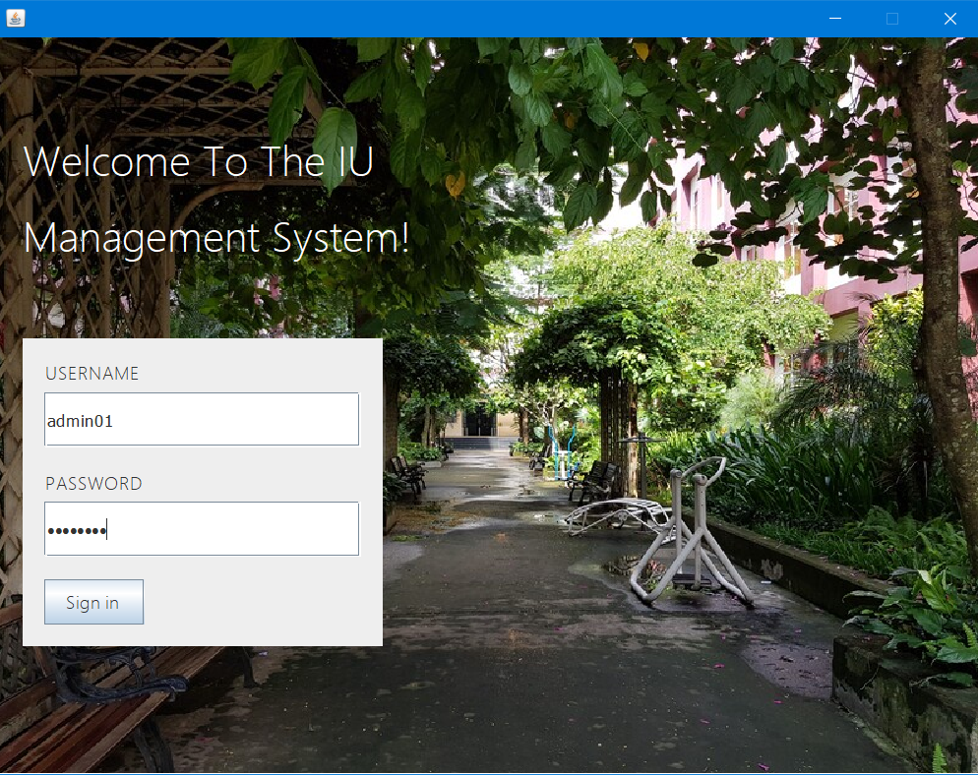

+ If they are an admin, here is the menu:

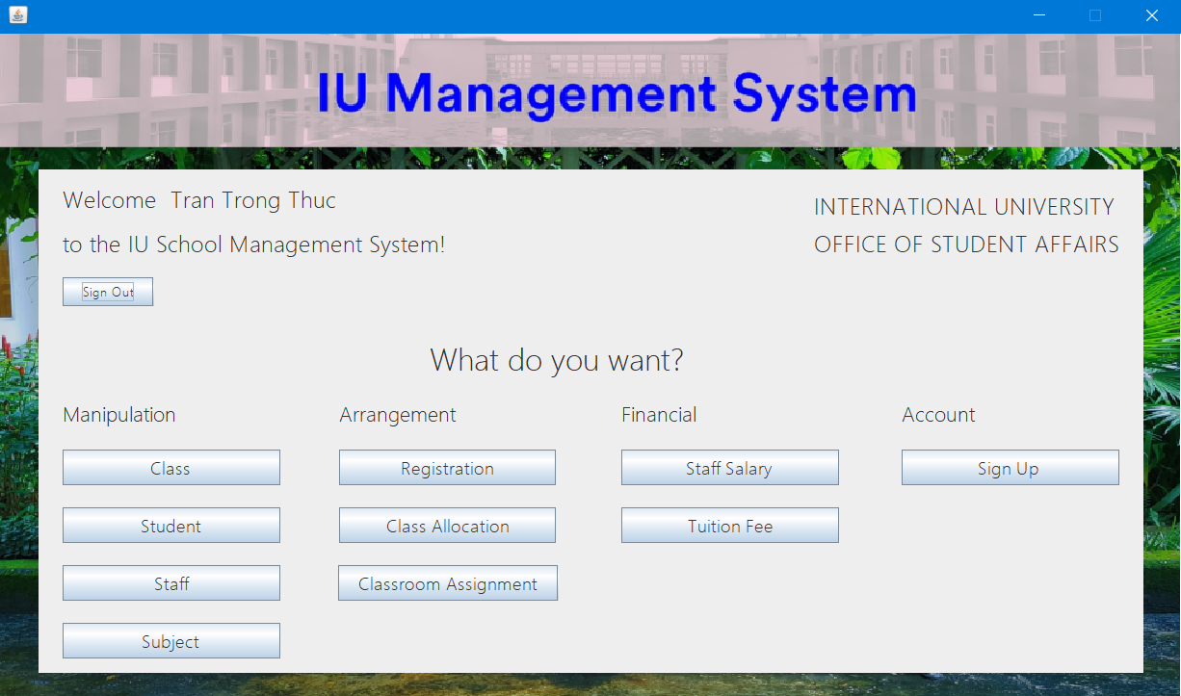

+ If they are a student, here is the menu:

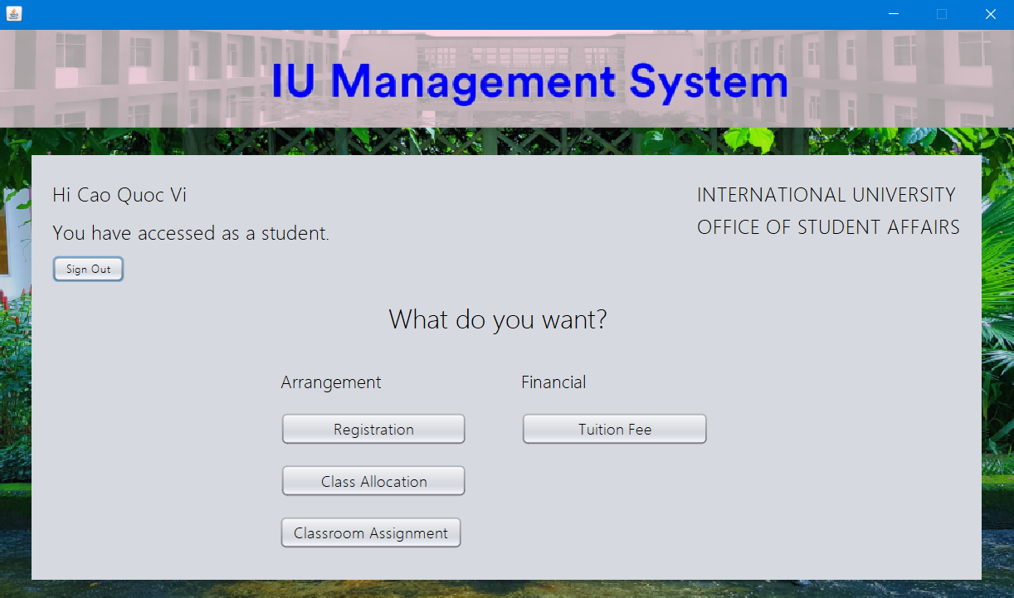

+ If they are a staff, here is the menu:

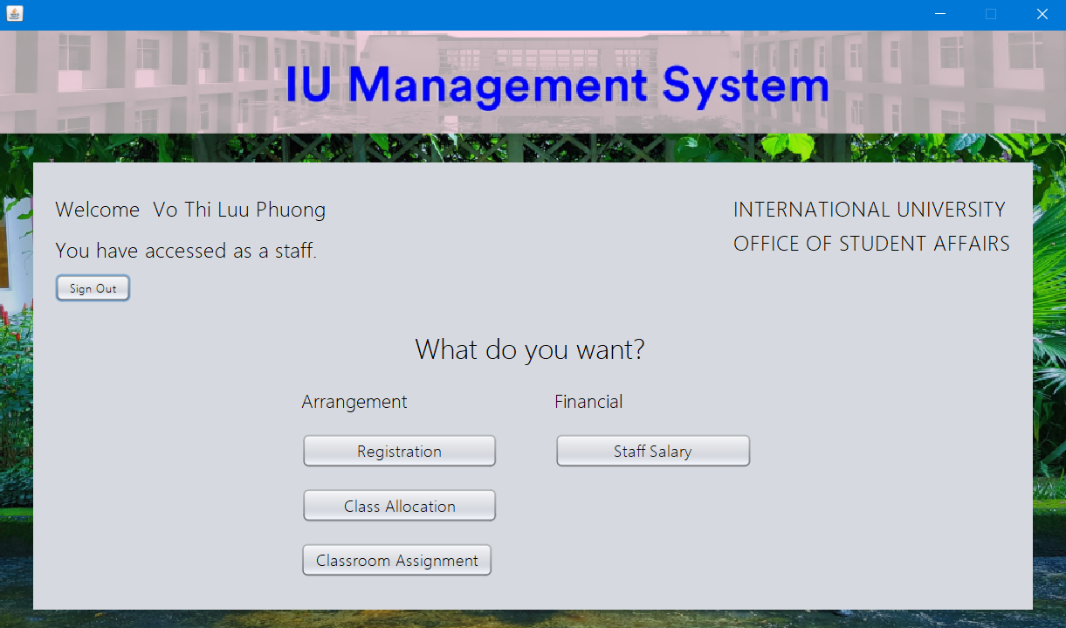

Access rights:

* An admin has full rights to edit/manipulate the database, including special rights like creating an account (It should be noted that this is a school management database, so, for a normal person, it is impossible to arbitrarily create an account to gain access to the database).

*For example, an admin can do such these things: (add/delete/update)

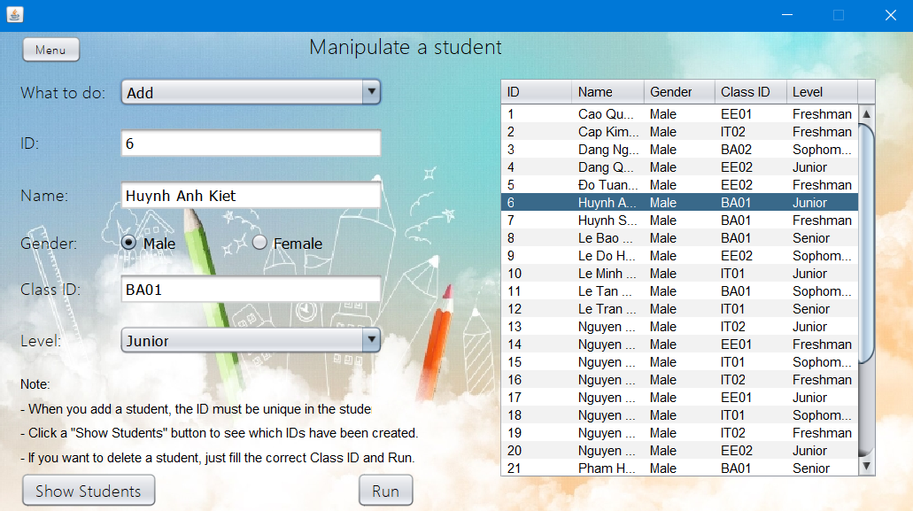

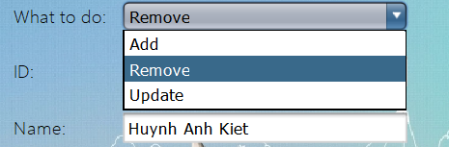

*A super admin right is to create an account, they can create a student account, staff, and even an admin account, however, the people who have been granted this admin account can only do this similar works if they have access code:

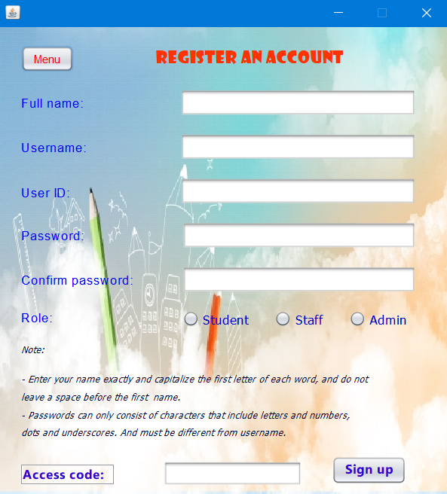

* A student can register for a course, as long as he pays the course fee by a certain deadline and makes sure he/she does not register two courses of the same name (Note: unlike admin and staff, he can only edit his own information only). In addition, he/she can view his/her subject organization, assignments and tuition status.

*For example, this student tries to delete someone’s registration, which is not allowed to:

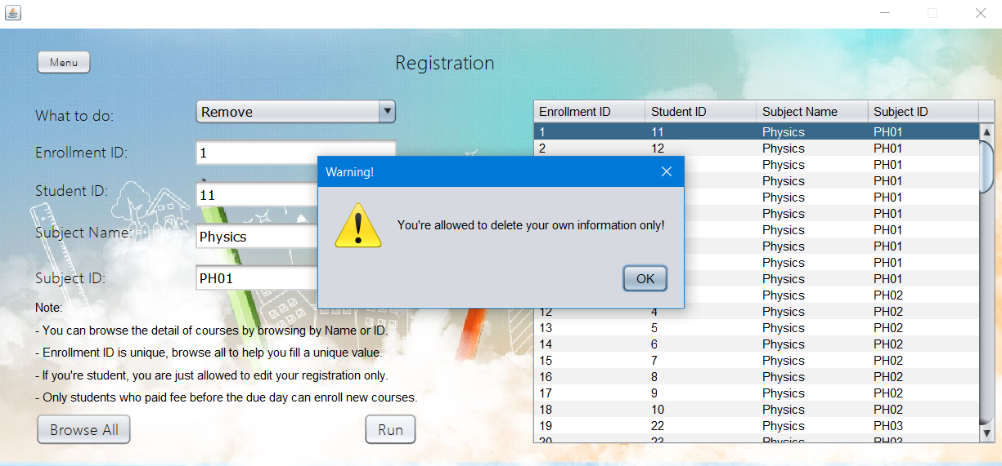

*The same for adding a registration:

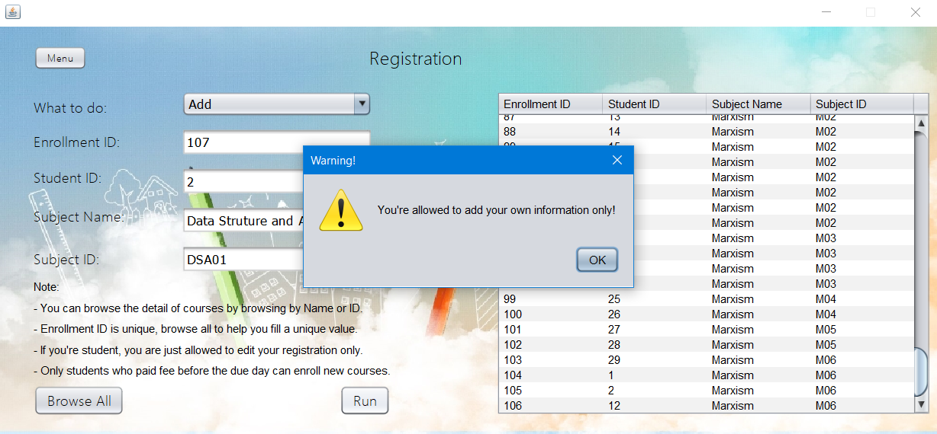

*In some functions, we have added browse buttons (all, by name, by ID) to help users to be able to operate correctly with the system, to avoid having to retype. Here is an example of “Browse” with “by subject name” or “by subject ID”.

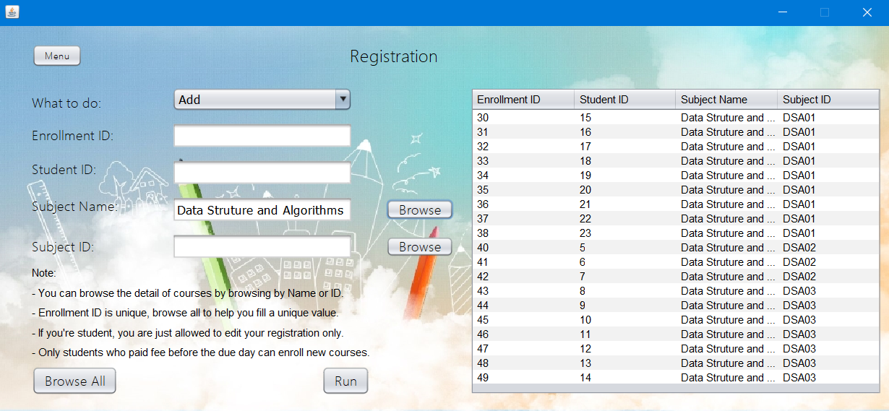

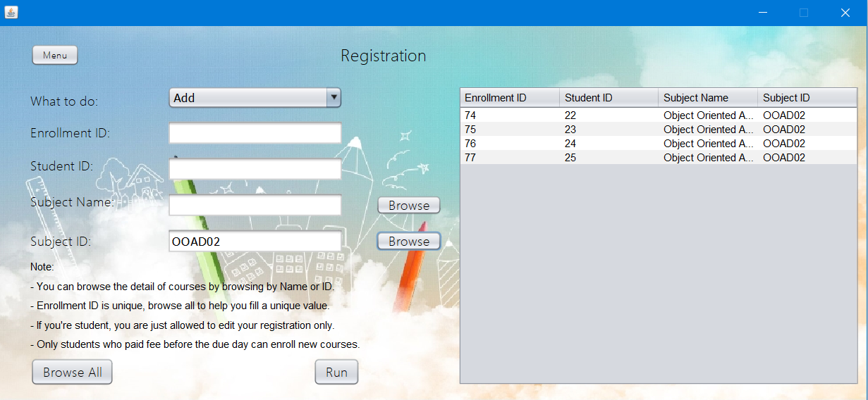

*Some functions may be restricted to students. For example, students can only view their own tuition, and cannot edit anything that not in their scope: (Cao Quoc Vi has logged in)

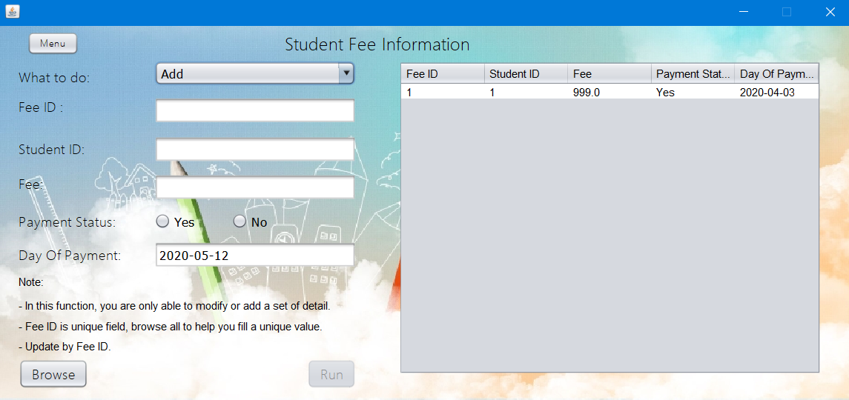

* An employee can register a course for students who need help, view their class information, create and edit their own assignments and of course, they can also see salary information.

*For example, this staff tries to delete another staff’s assignment, which is not allowed to:

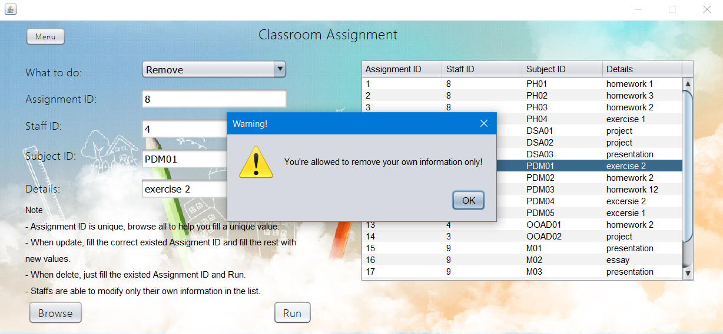

*The same for adding / modifying an assignment:

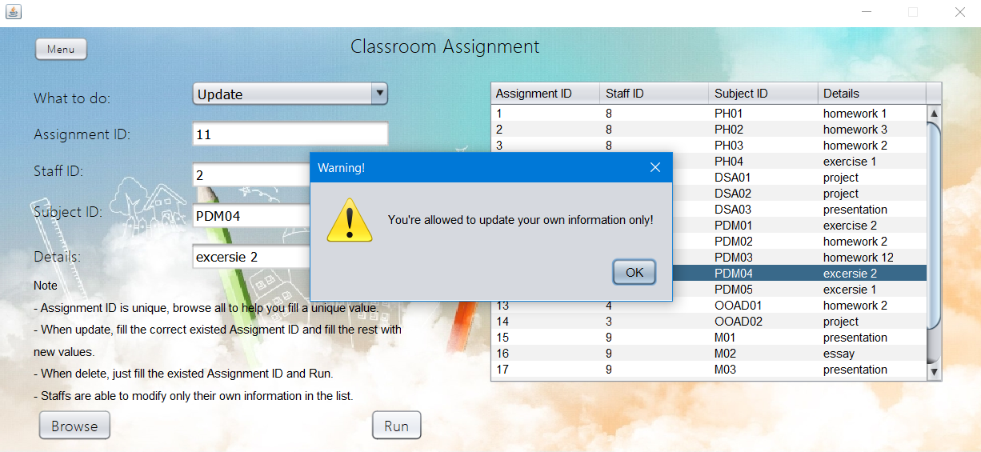

*Some functions may be restricted to staffs. For example, staffs can only view their own salary, and cannot edit anything that not in their scope: (Vo Thi Luu Phuong has logged in):

